s

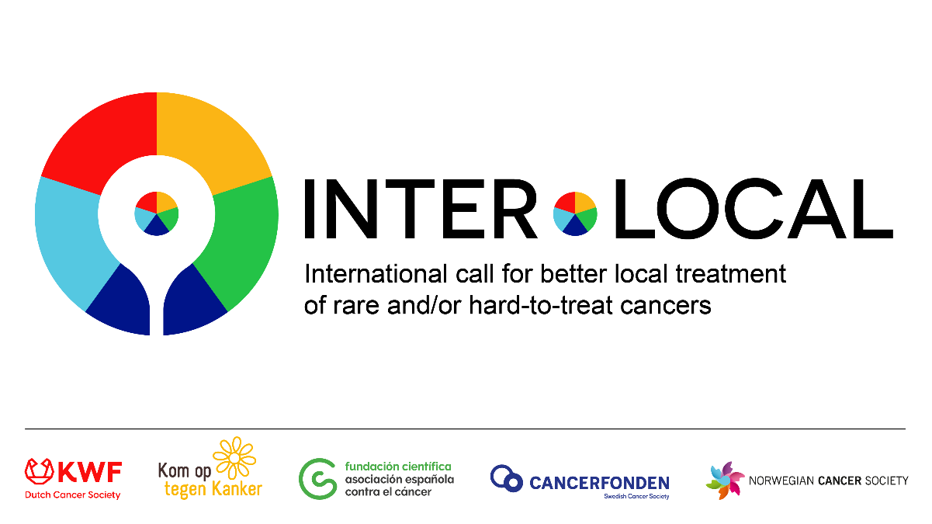

Pre-Proposal
Patient Advocacy Committee
Application Form

- This section of the pre-proposal application must be completed in layman's language, so that non-scientists, people without scientific/medical background, can read and assess the preproposal. Using layman's language not only ensures that the patient advocacy committee (PAC) gets a clear and structured representation of your project, but also gives the PAC an idea of the way the researcher communicates with patients. Please note that the PAC will only evaluate this application form. They do not have any insight into the scientific application form, nor any appendices or references attached to the scientific application form.
- When writing a project application, it is important that all evaluation criteria are filled in and interpreted correctly. If certain criteria require additional clarification, please do not hesitate to contact us.
- The concrete guidelines for drawing up a patient-oriented project (application), which meets the requirements of the PAC, can be found in the Guidelines on Patient Centricity & Patient Involvement.
- If you would like more information about this application and/or the PAC, you can always contact the contact person of your local funding organization).

1 | General Information about the project
Project title
Project leader
Research institution of the project leader
Duration for the project
Requested budget
Participating countries and centers

2 | Glossary
Please clarify important terms/words and abbreviations mentioned in the application form here:

•
•
•

3 | Summary of the project (in layman’s language) max. 300 words

4 | Patient relevance

Who are the patients and what type(s) of cancer are involved? What is the current situation for these patients (in terms of diagnosis, treatment, side effects, ...)*? What are the needs of the patients that this project wants to address? max. 200 words
*When using numbers, please state the source
What is the aim of the project? How are you going to achieve this? max. 200 words
What will be the (potential) impact of the trial results on these patients' lives? max. 200 words

5 | Patient burden

Which interventions will the participating patients receive in this project? What are the possible risks and side effects? Explain why the benefits of this therapy outweigh the possible risks and side effects. max. 300 words
What actions will be taken to minimize the burden (travel burden, number of visits, side effects, ...) for the participating patients? max. 300 words

6 | Patient participation
Please note that we do not refer to the participation of patients in the clinical trial.
For more information and background on patient participation, as well as how to achieve it, please consult the ‘Guidelines patient centricity and involvement’

how will patient involvement contribute to the research project? Please note that we do not refer to the participation of patients in the clinical trial. max. 200 words
Specify the actions that have already been and will be taken to actively involve patients in the preparation of the project. max. 200 words
Specify the actions that will be taken to actively involve patients during the conduction of the project. max. 200 words
Patient dissemination: specify how the results of this project will be communicated to cancer patients and the cancer community. max. 200 words

